Three-Tier Architecture (Smart City)

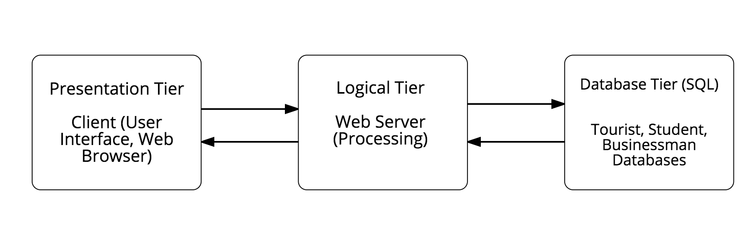

Controls application functionality by performing detailed data processing between Presentation Tier and Database Tier

Houses database servers of each individual type of users, where information is stored and retrieved. (DBMS)

Display information and related services available on the Smart City Website. Communicates with other tiers.